It is finally here!

ZOOM Live Transcription/Closed Captioning is available! Please urgently update your settings to improve the immediate accessibility of education and make our learning environment more inclusive!

- Navigate to: https://bostonchildrens.zoom.us/profile/setting
- Select: In Meeting (Advanced)
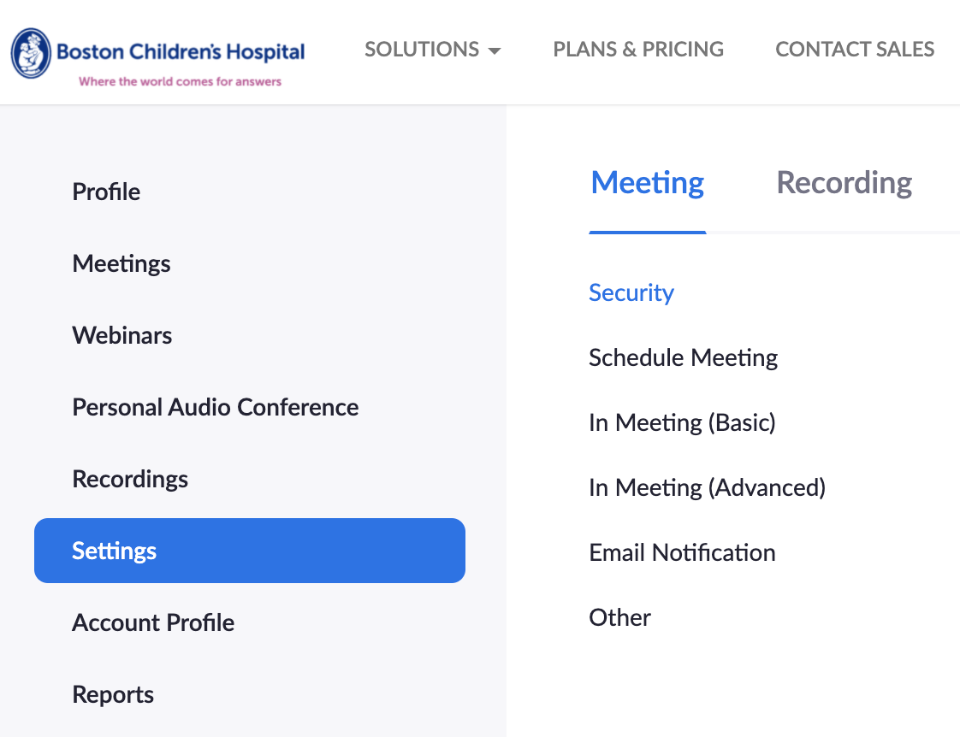

- Scroll down to: Close captioning
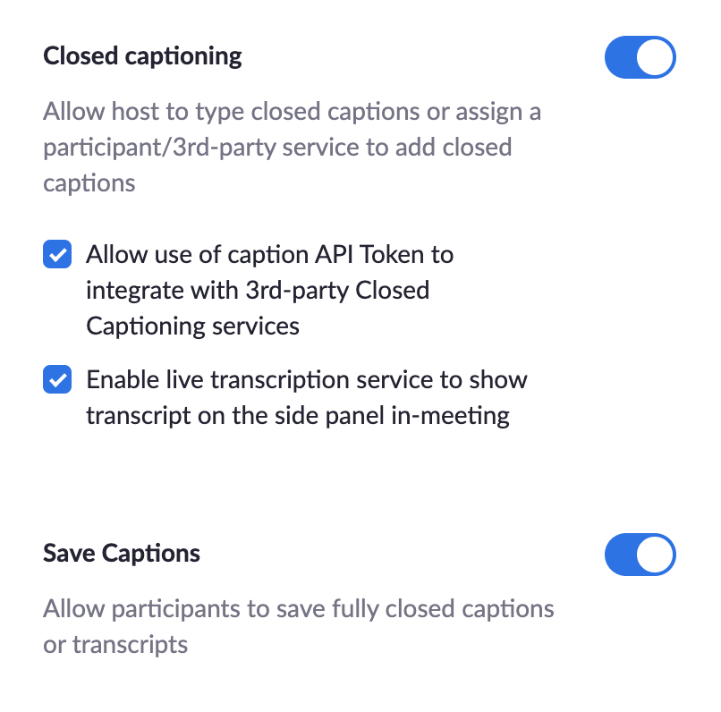
- Select:
- Allow use of caption API token to integrate with 3rd-party Closed Captioning services
- Enable live transcription service to show transcript on the side panel in-meeting
- Save Captions ON

- Ensure all settings are saved by opening an upcoming zoom to ensure live transcription is enabled and working!

When in the zoom meeting, as the host of the meeting, you should now see a “Live Transcript” button in your Zoom toolbar. Click that and then click to “Enable Auto-Transcription”. You can further modify the size and location of the transcription in your personal meeting setting within the zoom.




